Business Problem: Goal of this study is to find an Indian Restaurant among most popular restaurants in Bronx.

Data Collection: As Bronx is one of the Borough of New York City, New York City Neighborhood data was acquired from <https://geo.nyu.edu/catalog/nyu_2451_34572> to get addresses of neighborhoods within Bronx. Also, Foursquare API was used to generate location data for Bronx.

Methodology: k-Mean Clustering was used to form 5 clusters of Bronx

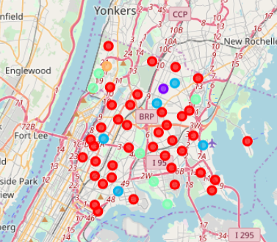

Results:

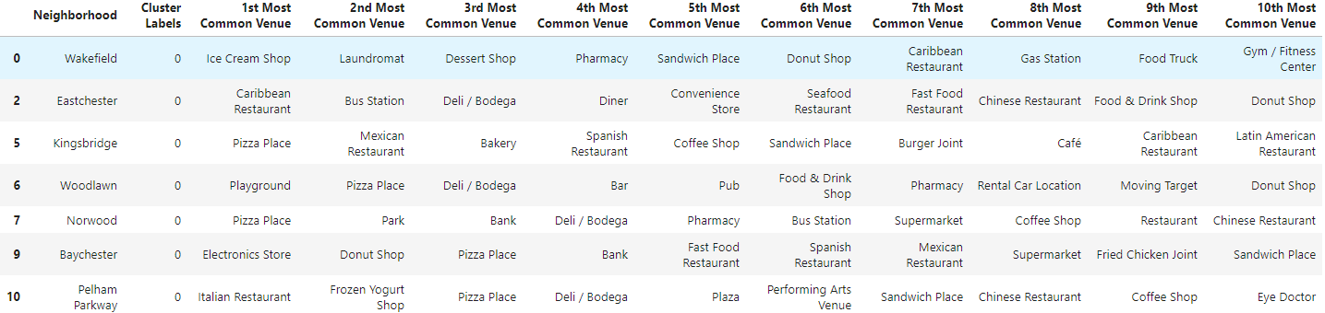



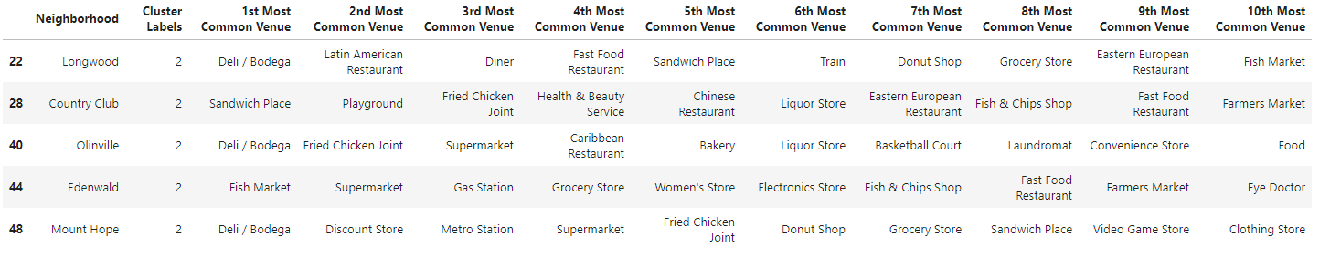

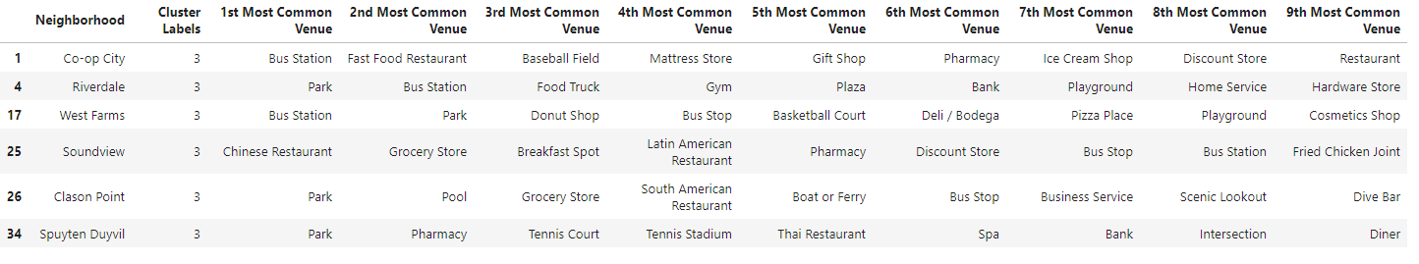



Discussion:

Each Cluster was examined for popular venues visited by most people. Cluster 1 had Pizza place was most common top avenue. In Cluster 2, Caribbean Restaurant was top venue. Cluster 3, Bodega were popular common venues. Parks were most top ranked venues. Cluster 5 had plaza as top ranked venue. None of Cluster had any Indian restaurant among 10 top venues.

Conclusion: based on results of these study, Indian restaurants are not popular in Bronx. These raises two new questions: 1. Why are Indian Restaurants not popular in Bronx 2. If one were to start Indian restaurant in Bronx, which Neighborhood is suitable? These questions will be answered by further study of Bronx taking into consideration demographics, income, and employment among some of the factors.